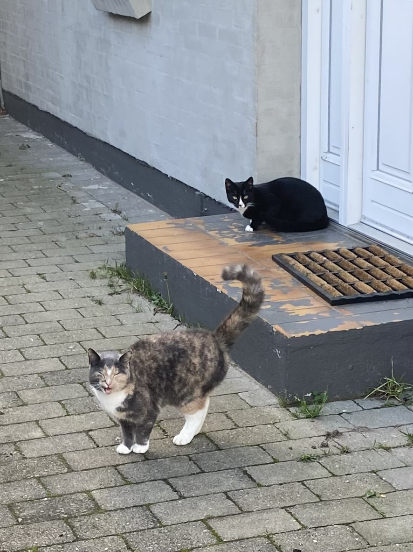

**Cat Detector**

**Monitoring Front Door Area Using PIR Triggered Video Capture**

**and Machine Learning Classification**

**Process Report**

**Course: 4510 H4 DAKP**

**Name: Tianzuo Wang**

**Date: 14 January 2026**

1. **Background and Motivation**

Several cats visit my garden regularly; they tend to walk by or stay at the front door a bit. One cat visit very frequently (I call her Hana as she has a multicolored coat), some weekends she appears multiple times per day. I am curious about how often Hana comes by, is it really her every time, or are there other cats, too?

1. **My Solution**

I plan to set an Arduino with a PIR sensor located near the front door (hanging on the window frame in the shed, high enough so cats can’t reach it). Each time motion is detected, a signal will be sent via Wi-Fi to a MQTT cloud broker. Raspberry PI subscribes to this channel and takes a photo using pi camera whenever it receives a signal.

The photo is then analyzed by a machine learning model to determine if this is Hana or other cats. The result (isHana, timestamp, confidence percentage, etc.) will then be saved to database. Overtime, I will be able to see statistics like how many times visit Hana, or a percentage of Hana’s visit out of last 10 motion detections.

I decided to use Pi camera instead of Arduino camera module for better photo quality. The camera and Raspberry Pi will be in the shed, camera pointing outside window.

1. **Model training**

I will train the model on my laptop using around 40-50 photos I already have of Hana, plus some photos of some other cats for comparison.

Since the camera angle is quite high and may not capture the cat's face clearly, I plan to train the model based on color distribution analysis (Hana's unique coat pattern) instead of facial features.

1. **Limitations**
   1. I need to make sure the shed is Wi-Fi-covered.
   2. PIR sensor will be outside, and needs protection against weather (wrap it in plastic film maybe)
   3. Pi camera v1.3 has no flashlight, risks for poor quality when it is dark outside.
   4. Limited amounts of photos for model training.
   5. High camera angles might capture only parts of the color pattern and confuses the model.
   6. PIR sensor only detects motion, so if cat sits still, or walks around, need for introducing visit types (like visit, or stay)
2. **Project Development Timeline**

**5.1 Set Raspberry PI as Nginx Web Server, host a simple test website**

**5.2 Set up SSH key authentication (passwordless login)**

**5.3 Initial Dashboard Setup:**

- Set up Raspberry PI dashboard showing real-time stats

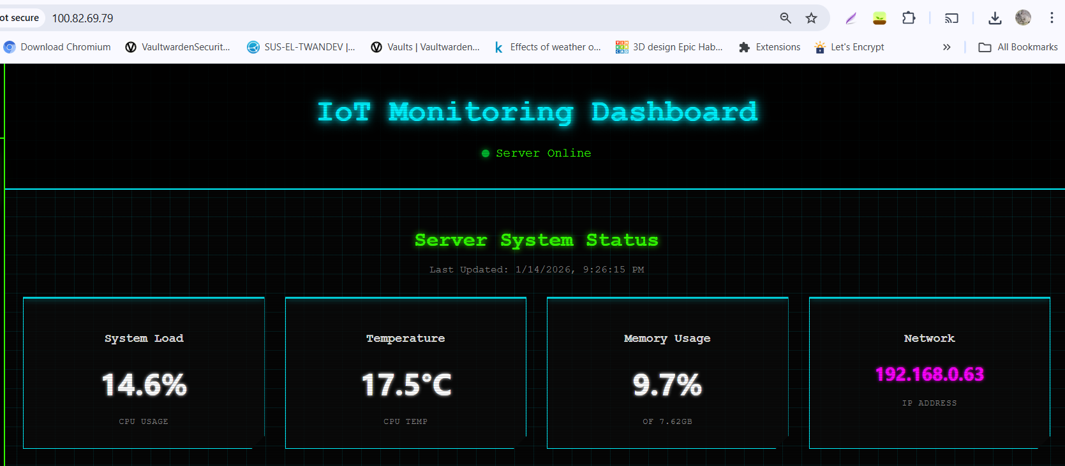

* Configured Tailscale VPN (100.82.69.79) for remote access, also download Tailscale on mobile phone to check server status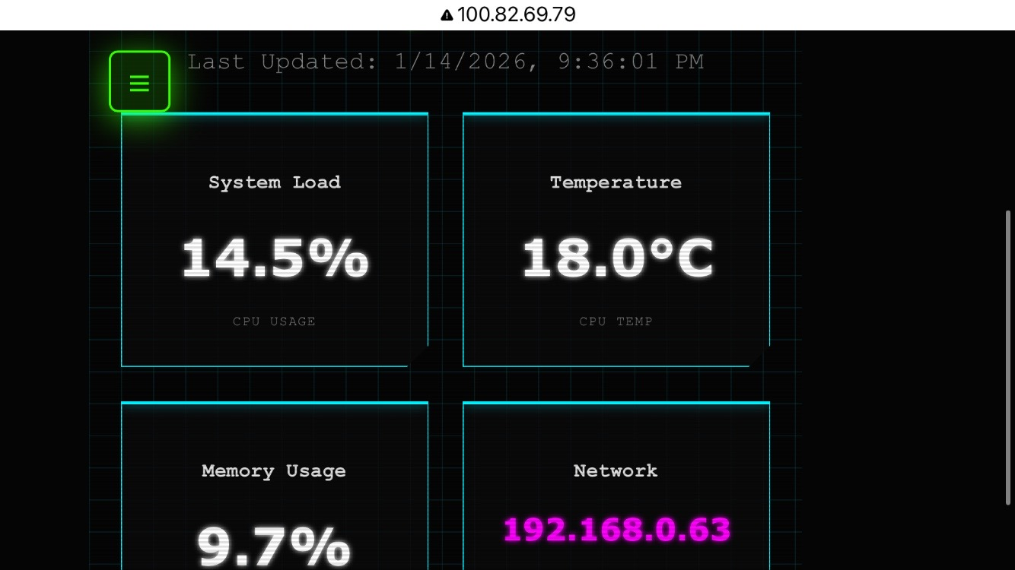
  1. **GitHub Auto-Deployment**

- Using Webhook for auto deployment on server on push

- Created Ngrok tunnel for webhook endpoint, as Github cannot reach Tailscale Ips

* 1. **January 8, 2026: Project changed to Cat Detection**

- Decision: changed project focus to IoT and Edge computing

- Goal: Track Hana’s visit to the front door

**5.6 January 9, 2026: Raspberry PI and Arduino network setting from school to home**

- Hardware set up: sensor and camera

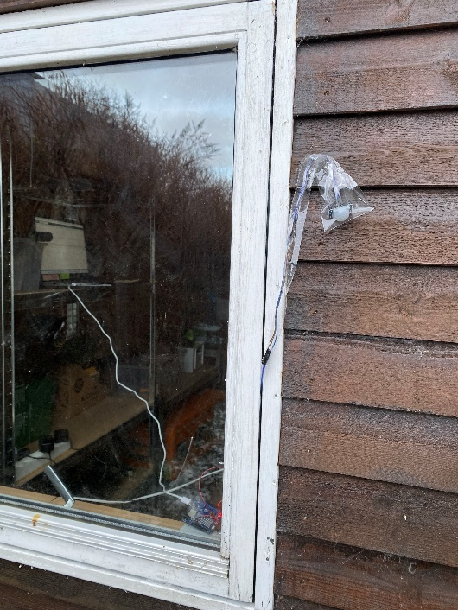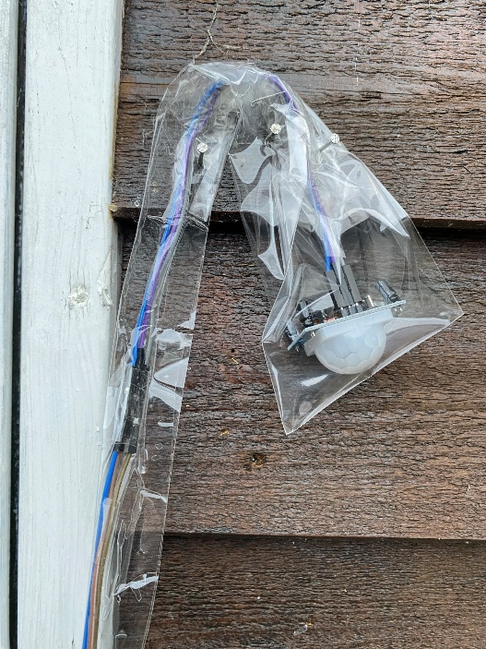

- Problem 1: protect PIR sensor outdoor, using plastic bag

- Problem 2: Camera angle needs further adjustment, higher and more pointing to front door

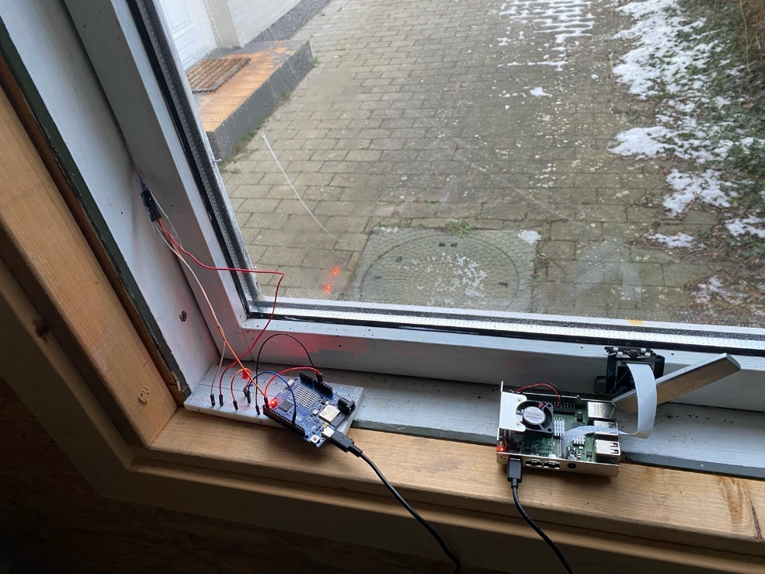

**5.7 January 10, 2026: PIR sensor protection and angle**

- Sensor packed inside a paper box, lower to the ground to better capture cat movements

- Use tape to set camera up inside the window for better photos

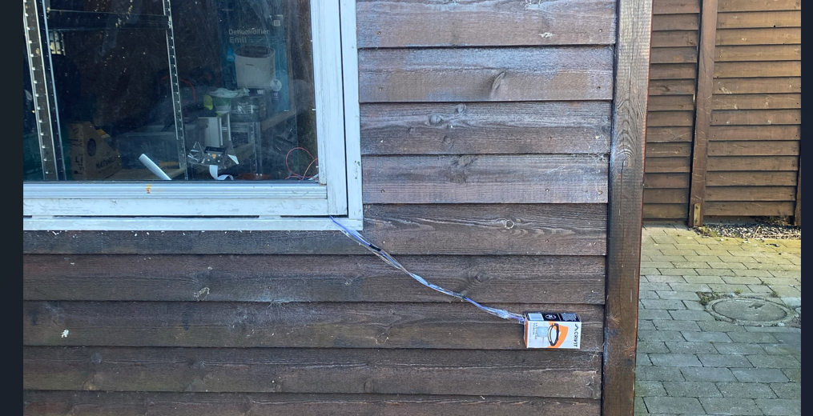

- Update UI for Arduino status, better monitoring Wi-Fi, MQTT connection status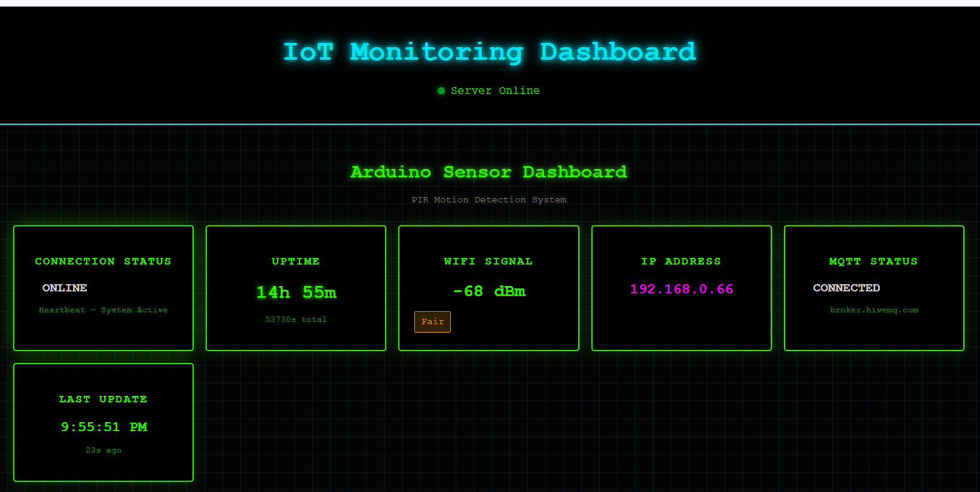

**5.8 January 11, 2026: Adjust PIR sensor location to the door side**

- problem: cat seems not always passing by window side of the shed, remounting to the door side, hoping to capture more cat activities.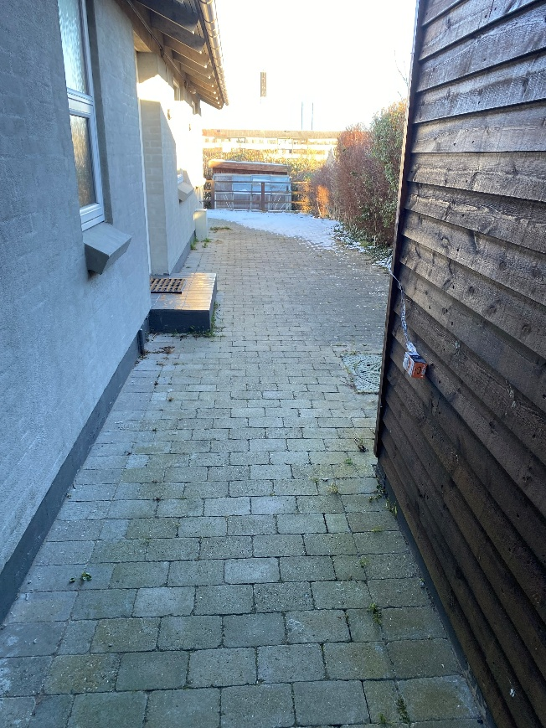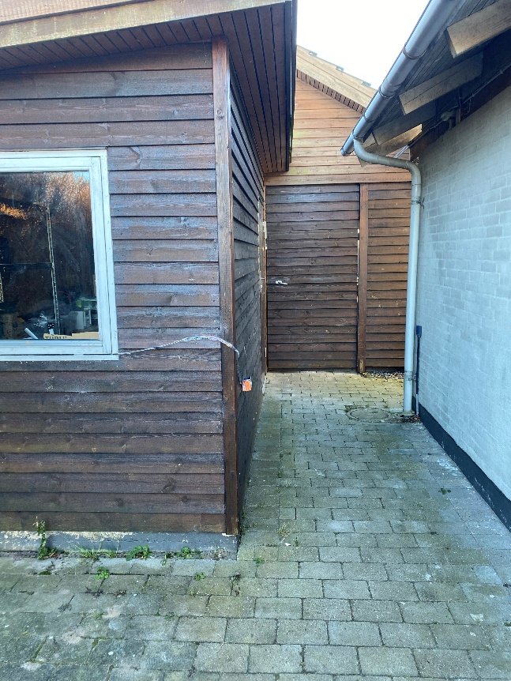

**5.9 January 12, 2026: Add second PIR sensor, get data for model training**

- problem1: Not enough qualified pictures for model training, considering using videos for richer data

- problem 2: reflection of light in glass. Set some cardboard inside the window

- problem 3: cat seems not always passing by window side of the shed, mounting an extra PIR sensor to the door side, hoping to get more cat activities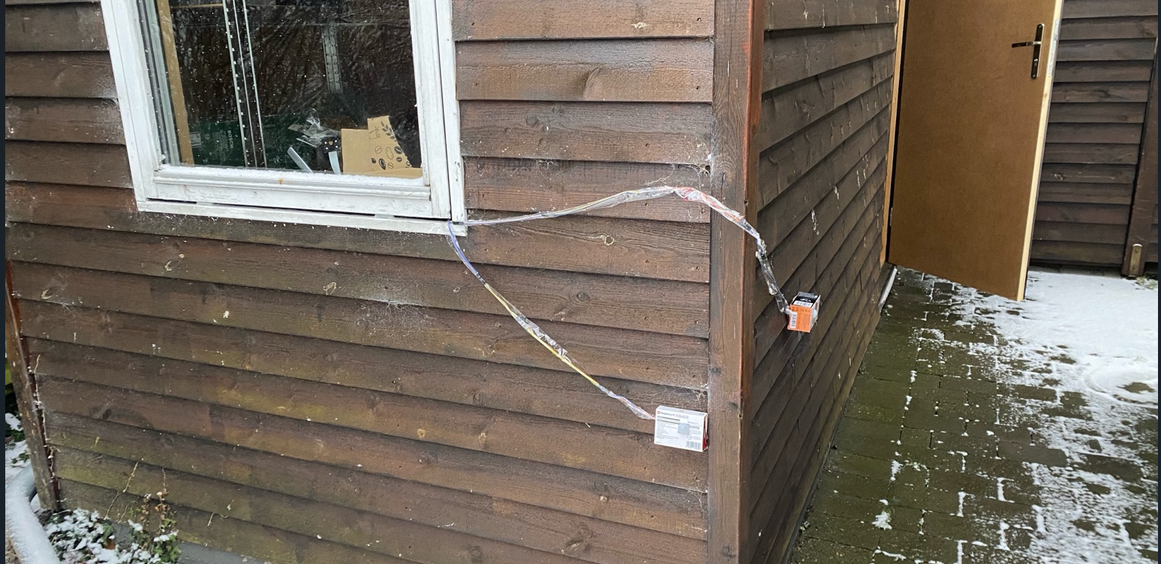

**5.10 January 13, 2026: Adjust second PIR sensor angle, mount Wi-Fi Extender**

- problem1: adjust sensor 2 angle, more facing the front door, and make sensor 1 more pointing to the ground, to better catch cat movements.

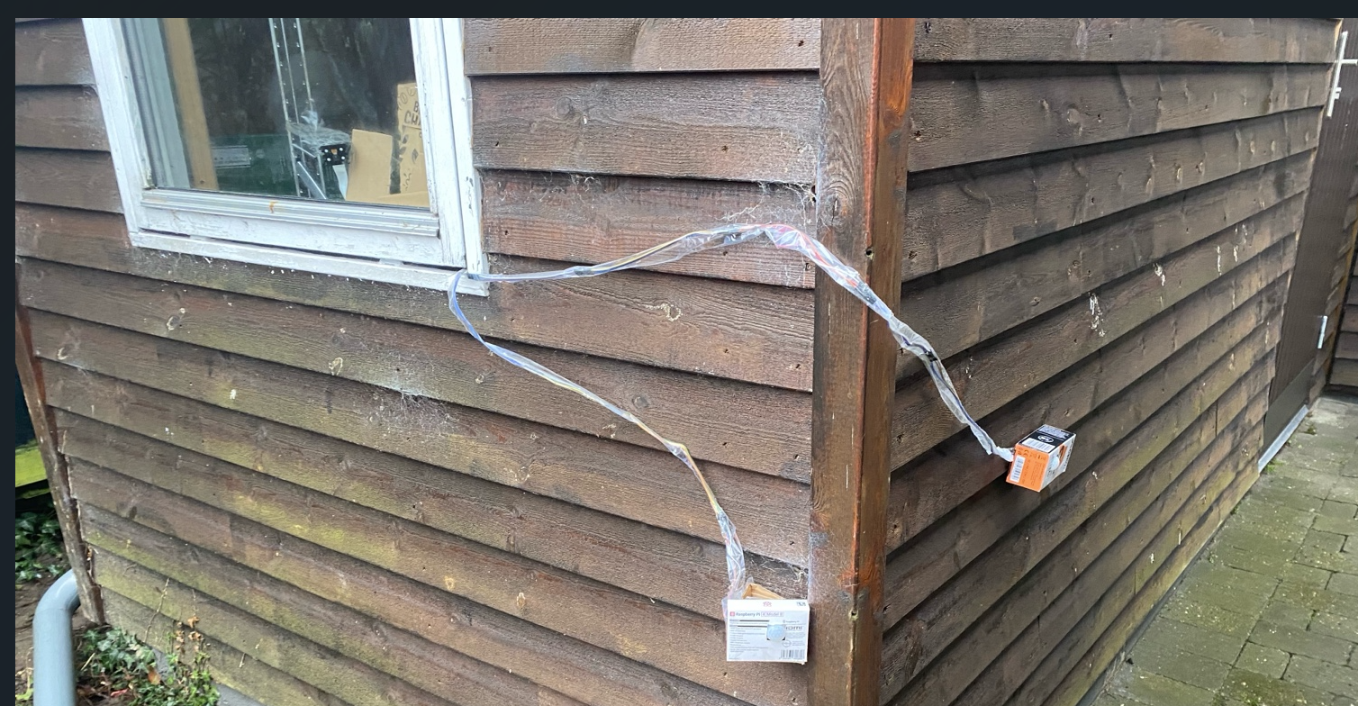

- problem 2: on motion detection, the sensor triggers a 5s video recording rather than a single photo, providing richer data for model training (10 frames from each video).

- problem 3: PI camera v1.3 records raw .h264 video, must be converted to mp4 before it can be viewed on browser

- problem 4: extra sensor means modification in database

- problem 5: Arduino is very unreliable on connecting to Wi-Fi in the shed, always offline, RSSI is at -79 to -86 range. A TP-Link RE305 Wi-Fi extender was added to extend the 2.4GHz coverage. Problem Fixed.

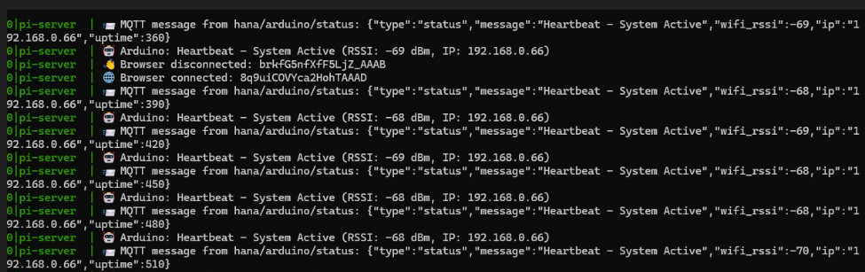

**5.11 January 14, 2026: Hardware network changing, Model training**

- problem1: Arduino reconnects to the old network, causing disconnects. So I renamed extend network and moved both PI and Arduino to the extender SSID to make sure they are on the same network and removed old SSID credentials from Arduino to prevent fallback.

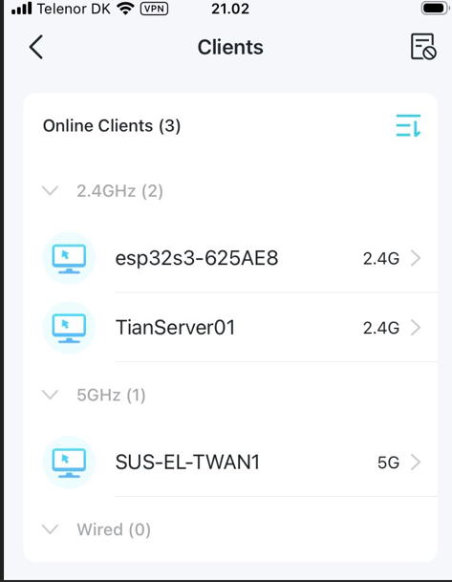

- problem 2: Model training

- Problem 3: rain on the glass blurs the PI camera footage, I can do nothing at school

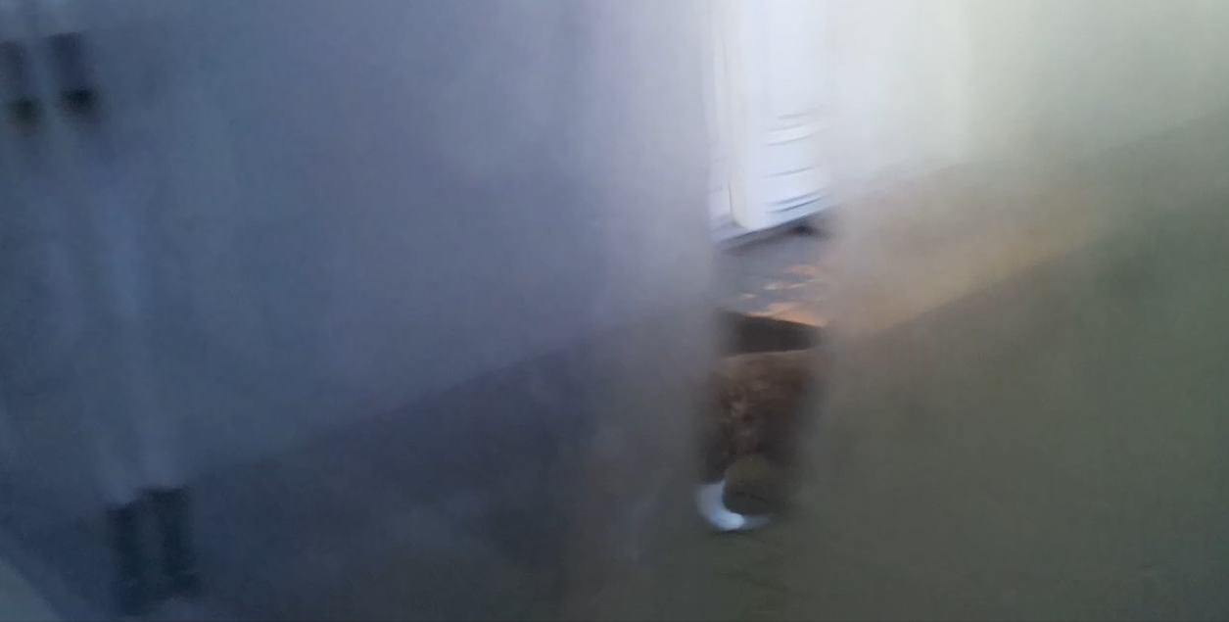

- Problem 4: update UI to show videos

- Problem 5: when it is dark, the picture is all dark. Impossible to recognize

